Ideation Phase
Define the Problem Statements
Date | 28 September 2026
Team ID | SWTID-2026-9038
Project Name | Script-Controlled ACL – Restrict Record Access Based on Field Value
Maximum Marks | 2 Marks

Team Leader: K. Kumutha | Members: R. Siva Dharshini, S. Vayshavi, M. Jasmin
Customer Problem Statement Template:
Create a problem statement to understand your customer's point of view. The Customer Problem Statement template helps you focus on what matters to create experiences people will love.
A well-articulated customer problem statement allows you and your team to find the ideal solution for the challenges your customers face. Throughout the process, you'll also be able to empathize with your customers, which helps you better understand how they perceive your product or service.
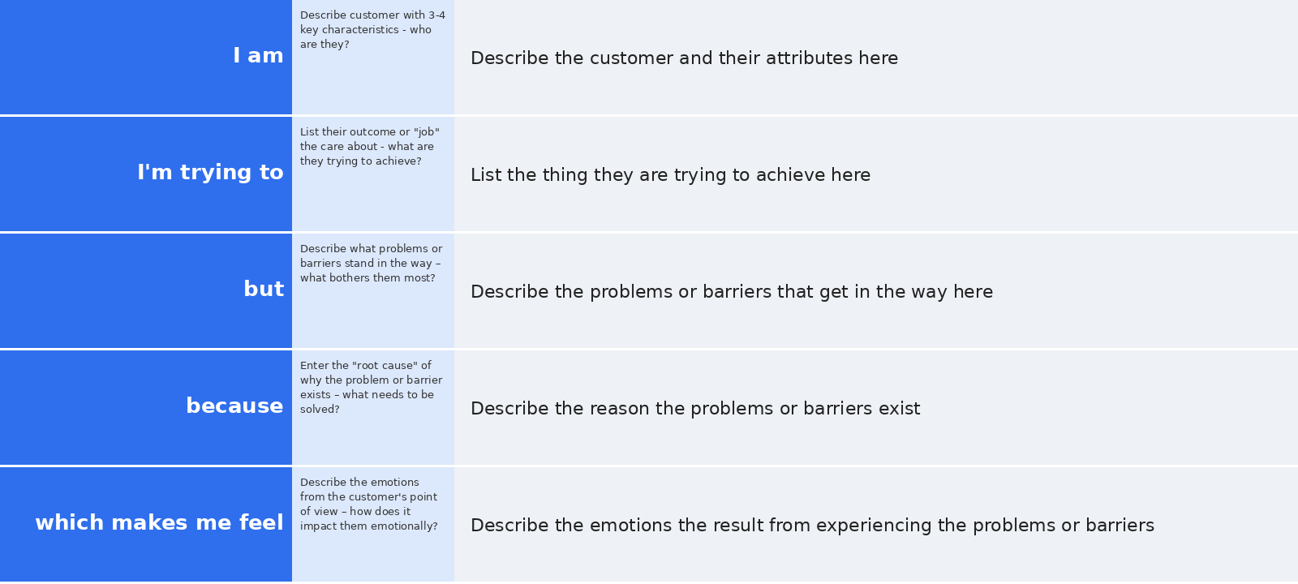
Reference: https://miro.com/templates/customer-problem-statement/
Example:
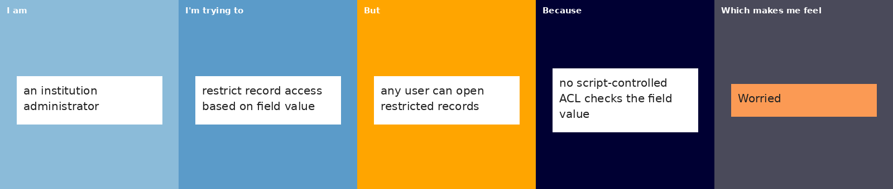
Problem Statements for the Project
Problem Statement (PS) | I am (Customer) | I'm trying to | But | Because | Which makes me feel
PS-1 | An institution administrator managing records in ServiceNow | Ensure that each institution record is visible and editable only by the authorised roles | Any user with basic access can open and read records that should be restricted | No script-controlled ACL checks the field value of the record before granting access | Worried and concerned about data security and privacy
PS-2 | A staff member (bb1–bb4 role user) working with institution details | View and update only the records that match my role and the record's field value | I can either see records I should not, or I am blocked from records I need | Access rules depend only on static roles and do not evaluate the record's field value | Frustrated and confused about why access is inconsistent

